
CHURCHLANDS SENIOR HIGH SCHOOL
MATHEMATICS SPECIALIST 3, 4 TEST ONE 2017
NON-Calculator Section
Chapters 1, 2,

Name________________________________ Time: 50 minutes
Total: 49 marks

1.[12 marks: 3,3,3,3]
Describe and sketch each of the following subsets of the complex plane.

a) $\left\{z:\left|z+1-i\right|≤3\right\}$
Description :

b) $\left\{z:\left|z+2-i\right|=\left|z-1+2i\right|\right\}$
Description:

c) $\left\{z:z\overline{z}=4\right\}$

Description:

d)$\left\{z:Rez-Imz≤9\right\}$

Description:

2. [ 6 marks: 2,1,1,1,1]

Sketch on the complex plane below the region defined by

Hence, find
i) the maximum value of $\left|z\right|$

ii) the minimum value of $\left|z\right|$

iii) the maximum value of Re(z)

iv) the minimum value of Im(z)

3. [7marks: 1,2,4]
i) Find the remainder when $x^{3}-4x^{2}+7x-6$ is divided by $x-2$.

ii) When $x^{3}-x^{2}+cx-3$ is divided by $x-3$, the remainder is 30. Find c.

iii) When $3x^{3}-ax^{2}-bx+1$ is divided by $x-2$, the remainder is 15. If $x-1$ is a factor of the given polynomial, find the values of $a$ and $b$.

4. [2 marks]
Plot the roots of $z^{8}=1$on the Argand diagram below.

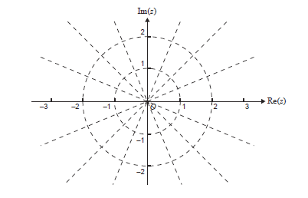

5. [4 marks:1,2,1]

Let $β=1-i\sqrt{3}$.
i) Express $β$in polar form.

ii) Express $β^{5}$ in polar form.

iii) Hence express $β^{5}$ in the form $x+iy$.

6. [12 marks:3, 3, 6 marks]

(a) If $z_{1}=3cis\left(\frac{4π}{3}\right)$and $z_{2}=\frac{1}{2}cis\left(\frac{π}{6}\right)$, prove that: $\frac{z_{1}}{z_{2}}=-3(\sqrt{3}+i)$

b) Simplify $\frac{\left(3cis\frac{π}{3}\right)(4cis\frac{π}{2})}{6cis\frac{π}{4}}$ giving your answer in the form $rcisθ$.

c)
Find all $z=x+iy$, given that $z\overline{z}+3z=\overline{z}+4i$

7. [6 marks]
If $z=cisθ$ and by using De Moivre’s theorem together with knowledge of the binomial expansion to find $z^{3}$, show that $cos3θ=\cos^{3}θ-3cosθ\sin^{2}θ$ and $sin3θ=3\cos^{2}θsinθ-\sin^{3}θ$.

